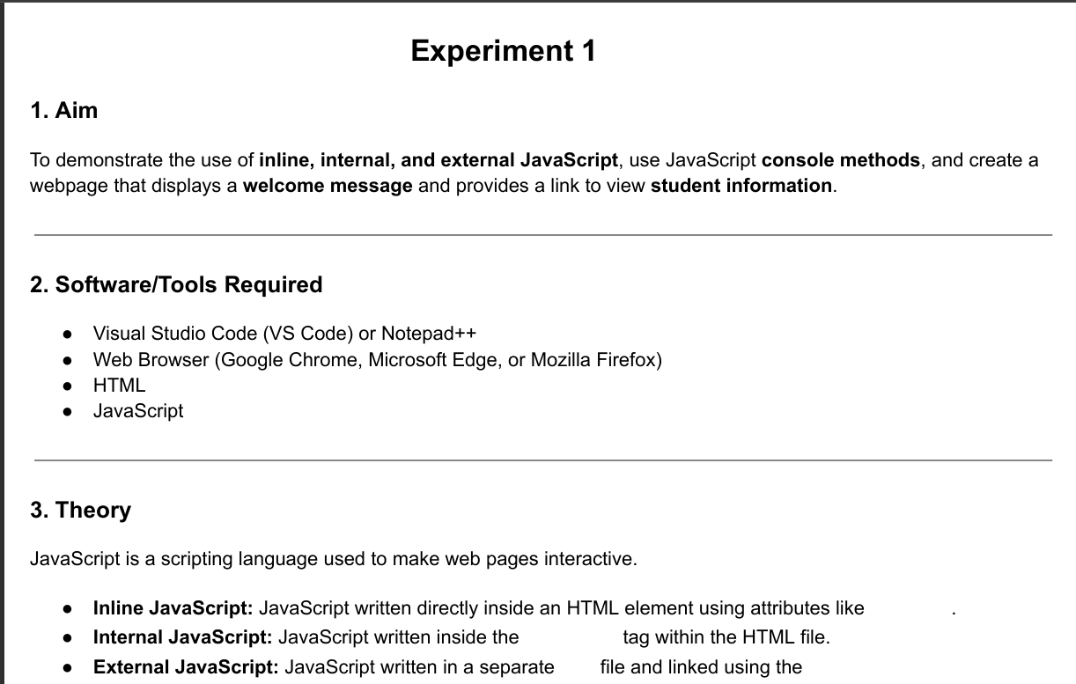
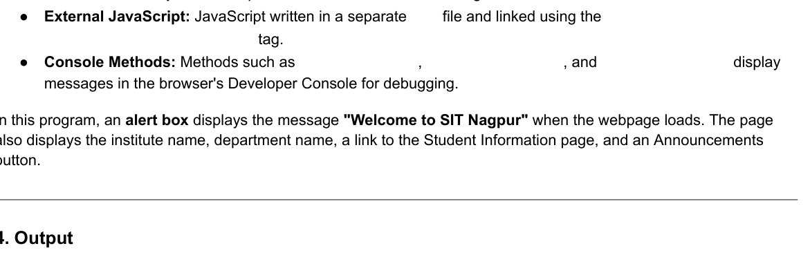
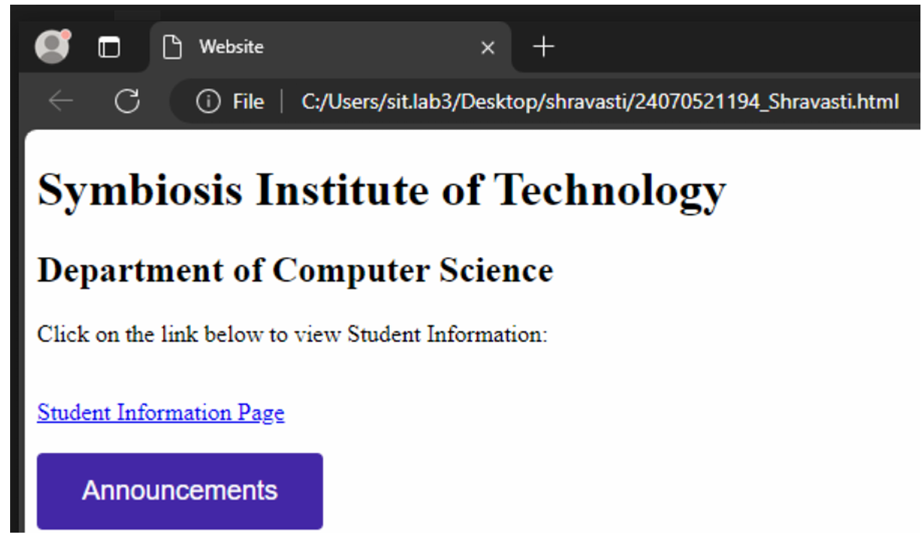
Case study 1
📝 1. Aim
To design and develop a responsive webpage for a college department using HTML and CSS, and to integrate JavaScript to display a welcome alert message upon page load while dynamically linking and fetching student information.

📚 2. Theory
Building an interactive portal requires a structured separation of concerns between front-end content layout, presentation aesthetics, and behavioral programming:
- HTML5 (HyperText Markup Language): Formulates the backbone and structural architecture of the web page. It uses semantic tags (like <header>, <div>, and <section>) to host structural information like the college name, department details, and data search containers.
- CSS3 (Cascading Style Sheets): Controls the visual design, spacing, layout, typography, and color palette. Applying clean box models ensures that the UI looks highly organized, readable, and behaves responsively across multiple screen devices.
- JavaScript (Client-Side Scripting): Enables browser-side interactivity and logical compute powers:
  - window.onload Trigger: An event listener that executes instantly once the DOM tree completes loading. By embedding alert("welcome to sit nagpur"); inside this lifecycle hook, the browser pops open an interactive modal message box before structural interaction begins.
  - Data Objects and DOM Manipulation: Instead of hardcoding text, student profiles are stored structured inside a JavaScript Key-Value schema dictionary (studentDatabase). When the user inputs a parameter (like a Roll Number) and hits search, JS intercepts the event, queries the dataset, updates HTML text targets via document.getElementById(), and flips CSS display properties dynamically without forcing a full page reload.

Code :
<!DOCTYPE html>
<html lang="en">
<head>
<meta charset="UTF-8">
<meta name="viewport" content="width=device-width, initial-scale=1.0">
<title>SIT Nagpur - Computer Science Department</title>
<style>
* {
box-sizing: border-box;
margin: 0;
padding: 0;
font-family: 'Segoe UI', Tahoma, Geneva, Verdana, sans-serif;
}
body {
background-color: #f4f6f9;
color: #333;
line-height: 1.6;
}
header {
background-color: #1a365d;
color: white;
padding: 2rem;
text-align: center;
}
header h1 {
margin-bottom: 0.5rem;
}
.container {
max-width: 1000px;
margin: 2rem auto;
padding: 0 1rem;
}
.section {
background: white;
padding: 2rem;
border-radius: 8px;
box-shadow: 0 4px 6px rgba(0,0,0,0.05);
margin-bottom: 2rem;
}
h2 {
color: #2b6cb0;
margin-bottom: 1rem;
border-bottom: 2px solid #e2e8f0;
padding-bottom: 0.5rem;
}
.search-box {
display: flex;
gap: 10px;
margin-top: 1rem;
}
input[type="text"] {
flex: 1;
padding: 0.75rem;
border: 1px solid #cbd5e0;
border-radius: 4px;
font-size: 1rem;
}
button {
background-color: #2b6cb0;
color: white;
border: none;
padding: 0.75rem 1.5rem;
border-radius: 4px;
cursor: pointer;
font-size: 1rem;
font-weight: bold;
}
button:hover {
background-color: #1a365d;
}
.result-card {
margin-top: 1.5rem;
padding: 1rem;
background: #ebf8ff;
border-left: 4px solid #3182ce;
border-radius: 4px;
display: none;
}
.result-card p {
margin: 0.5rem 0;
}
.error-text {
color: #e53e3e;
margin-top: 1rem;
display: none;
}
</style>
</head>
<body>

<!-- Header Section -->
<header>
<h1>Symbiosis Institute of Technology (SIT), Nagpur</h1>
<p>Department of Computer Science & Engineering</p>
</header>

<div class="container">
<!-- About Department Section -->
<div class="section">
<h2>About the Department</h2>
<p>Welcome to the Department of Computer Science & Engineering at SIT Nagpur. We offer world-class infrastructure, industry-aligned research opportunities, and a cutting-edge curriculum tailored to prepare students for the global tech landscape.</p>
</div>

<!-- Student Information Portal Section -->
<div class="section">
<h2>Student Information Portal</h2>
<p>Enter a Student Roll Number to view academic profile and current department database alignment:</p>

<div class="search-box">
<input type="text" id="rollInput" placeholder="Try entering: SIT001 or SIT002">
<button onclick="searchStudent()">Search Profile</button>
</div>

<!-- Box to display results dynamically -->
<div id="resultBox" class="result-card">
<h3>Student Profile Found</h3>
<p><strong>Name:</strong> <span id="resName"></span></p>
<p><strong>Roll Number:</strong> <span id="resRoll"></span></p>
<p><strong>Current Semester:</strong> <span id="resSem"></span></p>
<p><strong>CGPA:</strong> <span id="resCgpa"></span></p>
</div>

<p id="errorBox" class="error-text">No student found matching that Roll Number. Please try again.</p>
</div>
</div>

<!-- JavaScript Segment -->
<script>
// 1. Mandatory requirement: Welcome Alert Box on Page Load
window.onload = function() {
alert("welcome to sit nagpur");
};

// Mock Database linking student info
const studentDatabase = {
"SIT001": { name: "Aarav Sharma", sem: "4th Semester", cgpa: "8.9" },
"SIT002": { name: "Ananya Iyer", sem: "6th Semester", cgpa: "9.4" },
"SIT003": { name: "Kabir Verma", sem: "2nd Semester", cgpa: "7.8" }
};

// 2. Interactive Search Logic linking the UI to the Student Information Object
function searchStudent() {
const inputVal = document.getElementById("rollInput").value.trim().toUpperCase();
const resultBox = document.getElementById("resultBox");
const errorBox = document.getElementById("errorBox");

if (studentDatabase[inputVal]) {
// Populate data
document.getElementById("resName").innerText = studentDatabase[inputVal].name;
document.getElementById("resRoll").innerText = inputVal;
document.getElementById("resSem").innerText = studentDatabase[inputVal].sem;
document.getElementById("resCgpa").innerText = studentDatabase[inputVal].cgpa;

// Toggle view states
resultBox.style.display = "block";
errorBox.style.display = "none";
} else {
// Hide data cards and display error text
resultBox.style.display = "none";
errorBox.style.display = "block";
}
}
</script>
</body>
</html>

Output :

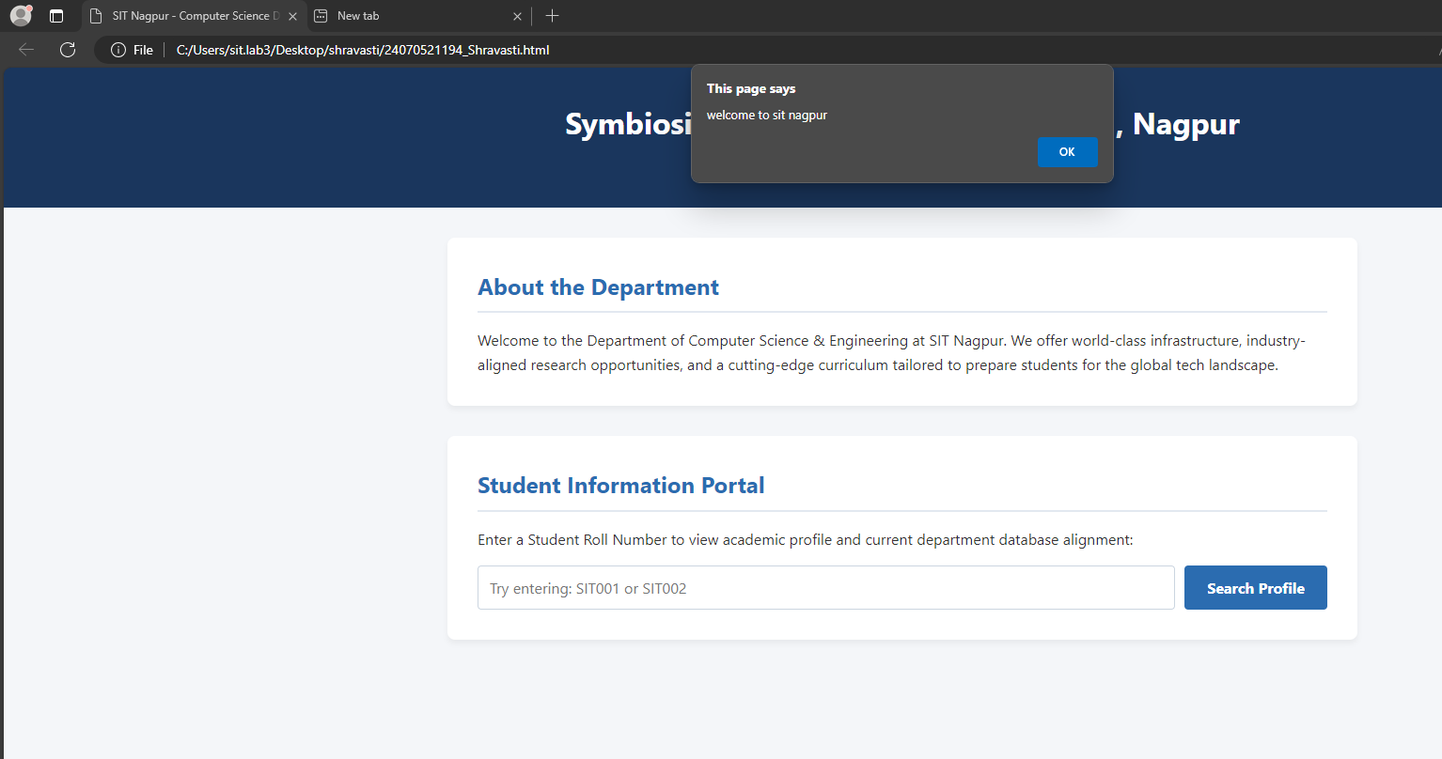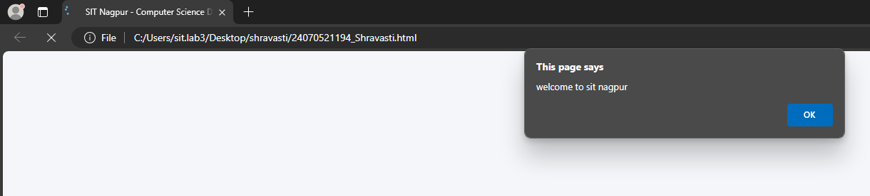
🏁 3. Conclusion
The objective of creating an interactive college department portal was successfully accomplished. The webpage efficiently displays department details, triggers the designated client-side welcome alert banner upon system initialization, and enables seamless, instantaneous matching of student query datasets. This structure showcases how simple client-side Javascript scripts can be paired with standard HTML/CSS structure to build highly functional user interfaces.

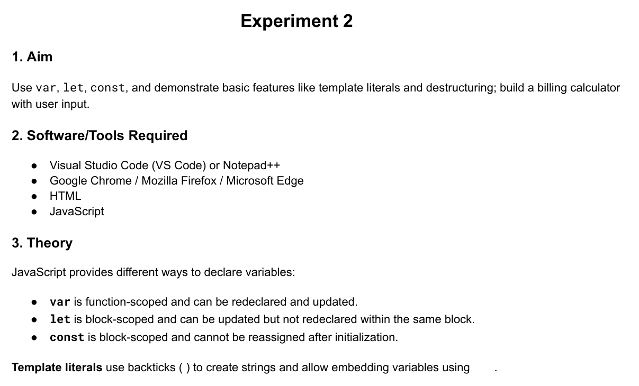
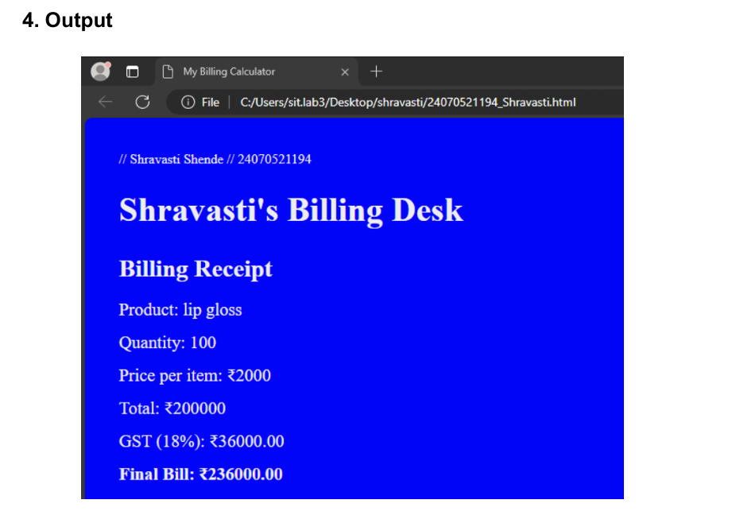
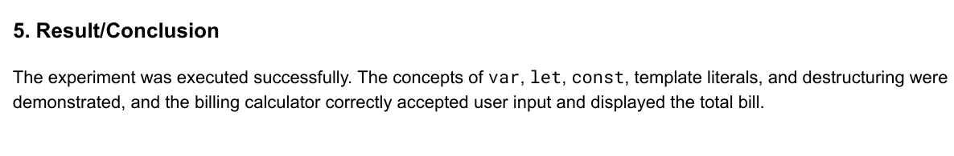
Case study 2

📝 1. Aim
To design and implement a responsive text-based Retail Invoice Billing Terminal using HTML5, CSS3, and JavaScript that captures customer data (Name and Phone Number) alongside dynamic product inputs (Name, Price, and Quantity) to compute and display a live paper-style receipt layout.

📚 2. Theory
Developing digital transaction desk software requires programmatic coordination between form input state management, algorithmic arithmetic operations, and real-time DOM structure rendering:
- Semantic Form Handlers (HTML5): Formulates text capturing blocks using <input> elements tied to concrete statistical metrics (type="text", type="number"). These controls accept explicit customer metrics and store unit costs securely before compilation.
- Monospaced Aesthetic Presentation (CSS3): By enforcing strict typographical styling rules via font-family: 'Courier New', monospace;, the web layout takes on the structured formatting signature of legacy thermal cash registers. A clean side-by-side flexbox configuration maps input fields on the left and the paper receipt output terminal cleanly on the right.
- Dynamic Data Pipelines & Arithmetic Engine (JavaScript):
  - Real-time Event Listeners: By attaching the oninput hook directly to identity tracking boxes, user keystrokes dynamically stream client attributes straight onto the billing header matrix.
  - Array Storage & Aggregate Math Logic: Individual product objects are continuously structured and appended into a centralized dynamic storage matrix (billedItemsArray).
  - Tax Formulation Rules: The programming script iterates through the records array to compute product sub-totals, appends a standard combined 18% Goods and Services Tax (GST) block, and pushes formatted string nodes back onto target HTML node IDs without breaking active window focus.

Code :
<!DOCTYPE html>
<html lang="en">
<head>
<meta charset="UTF-8">
<meta name="viewport" content="width=device-width, initial-scale=1.0">
<title>Retail Invoice Billing Terminal</title>
<style>
* {
box-sizing: border-box;
margin: 0;
padding: 0;
font-family: 'Courier New', Courier, monospace; /* Text/Receipt style font */
}
body {
background-color: #f1f5f9;
color: #1e293b;
padding: 20px;
}
.container {
max-width: 900px;
margin: 0 auto;
display: flex;
gap: 20px;
}
/* Left Panel - Entry Form */
.form-section {
flex: 1;
background: white;
padding: 20px;
border-radius: 6px;
box-shadow: 0 4px 6px rgba(0,0,0,0.05);
}
/* Right Panel - Live Receipt */
.receipt-section {
flex: 1;
background: #fffdf0; /* Paper color */
padding: 25px;
border: 1px solid #cbd5e1;
border-radius: 4px;
box-shadow: 0 4px 10px rgba(0,0,0,0.05);
}
h2 {
font-size: 1.2rem;
margin-bottom: 15px;
text-transform: uppercase;
border-bottom: 2px solid #1e293b;
padding-bottom: 5px;
}
.form-group {
margin-bottom: 12px;
}
label {
display: block;
font-size: 0.85rem;
font-weight: bold;
margin-bottom: 4px;
text-transform: uppercase;
}
input {
width: 100%;
padding: 8px;
border: 1px solid #94a3b8;
border-radius: 4px;
font-size: 0.9rem;
font-family: inherit;
}
button {
width: 100%;
background-color: #1e293b;
color: white;
border: none;
padding: 10px;
font-size: 0.9rem;
font-weight: bold;
cursor: pointer;
text-transform: uppercase;
margin-top: 10px;
font-family: inherit;
}
button:hover {
background-color: #334155;
}
/* Receipt Aesthetics */
.receipt-line {
display: flex;
justify-content: space-between;
margin-bottom: 6px;
font-size: 0.9rem;
}
.divider {
border-top: 1px dashed #475569;
margin: 12px 0;
}
.bold-text {
font-weight: bold;
}
.center-text {
text-align: center;
}
#itemsTable {
width: 100%;
margin: 10px 0;
font-size: 0.85rem;
}
#itemsTable th {
text-align: left;
border-bottom: 1px solid #1e293b;
padding-bottom: 4px;
}
#itemsTable td {
padding: 4px 0;
}
.empty-text {
text-align: center;
color: #64748b;
font-style: italic;
}
</style>
</head>
<body>

<div class="container">
<!-- Left Side: Order & Customer Input Controls -->
<div class="form-section">
<h2>1. Customer Details</h2>
<div class="form-group">
<label>Customer Name:</label>
<input type="text" id="custName" placeholder="Enter Full Name" oninput="updateReceiptMetadata()">
</div>
<div class="form-group">
<label>Phone Number:</label>
<input type="text" id="custPhone" placeholder="Enter Phone Number" oninput="updateReceiptMetadata()">
</div>

<h2 style="margin-top: 25px;">2. Add Product Items</h2>
<div class="form-group">
<label>Product Name:</label>
<input type="text" id="prodName" placeholder="e.g. Wireless Mouse">
</div>
<div class="form-group">
<label>Unit Price (₹):</label>
<input type="number" id="prodPrice" placeholder="e.g. 499">
</div>
<div class="form-group">
<label>Quantity:</label>
<input type="number" id="prodQty" value="1" min="1">
</div>
<button onclick="addProductItem()">Add Item to Bill</button>
<button onclick="resetBillSystem()" style="background-color: #ef4444; margin-top: 5px;">Clear Entire Bill</button>
</div>

<!-- Right Side: Clean Paper Text Invoice Summary Frame -->
<div class="receipt-section" id="receiptPrintArea">
<div class="center-text bold-text" style="font-size: 1.3rem;">SMART RETAILS LTD</div>
<div class="center-text" style="font-size: 0.8rem; margin-bottom: 10px;">Nagpur, MH, India</div>

<div class="divider"></div>

<!-- Customer Metadata -->
<div class="receipt-line">
<span>CLIENT NAME:</span>
<span id="recName" class="bold-text">--------</span>
</div>
<div class="receipt-line">
<span>PHONE NO :</span>
<span id="recPhone" class="bold-text">--------</span>
</div>
<div class="receipt-line">
<span>DATE :</span>
<span id="recDate"></span>
</div>

<div class="divider"></div>

<!-- Items Table Ledger Grid -->
<table id="itemsTable">
<thead>
<tr>
<th style="width: 45%;">ITEM</th>
<th style="width: 15%;">QTY</th>
<th style="width: 20%;">RATE</th>
<th style="width: 20%; text-align: right;">TOTAL</th>
</tr>
</thead>
<tbody id="receiptItemsBody">
<tr id="fallbackRow"><td colspan="4" class="empty-text">No items billed yet.</td></tr>
</tbody>
</table>

<div class="divider"></div>

<!-- Dynamic Balance Totals Row Configurations -->
<div class="receipt-line">
<span>SUBTOTAL:</span>
<span id="recSubtotal">₹0.00</span>
</div>
<div class="receipt-line">
<span>CGST + SGST TAX (18%):</span>
<span id="recTax">₹0.00</span>
</div>
<div class="receipt-line bold-text" style="font-size: 1.1rem; margin-top: 5px;">
<span>GRAND TOTAL:</span>
<span id="recGrandTotal">₹0.00</span>
</div>

<div class="divider"></div>
<div class="center-text bold-text" style="margin-top: 15px; font-size: 0.85rem;">*** THANK YOU FOR VISITING ***</div>
</div>
</div>

<!-- Core Interactive Operations Engine scripts -->
<script>
// Array keeping live context records active
let billedItemsArray = [];

// Stamp runtime instance localized timestamp
document.getElementById('recDate').innerText = new Date().toLocaleDateString('en-IN');

// Dynamically pass consumer metadata straight over to text view fields
function updateReceiptMetadata() {
const nameVal = document.getElementById("custName").value.trim();
const phoneVal = document.getElementById("custPhone").value.trim();

document.getElementById("recName").innerText = nameVal ? nameVal.toUpperCase() : "--------";
document.getElementById("recPhone").innerText = phoneVal ? phoneVal : "--------";
}

// Add user inputs safely into the array table matrix
function addProductItem() {
const name = document.getElementById("prodName").value.trim();
const price = parseFloat(document.getElementById("prodPrice").value);
const qty = parseInt(document.getElementById("prodQty").value);

// Primitive validation barriers
if (!name || isNaN(price) || price <= 0 || isNaN(qty) || qty <= 0) {
alert("Please check item fields. Name, valid price, and quantity are required.");
return;
}

// Push validation clear records down onto stack
billedItemsArray.push({
name: name,
price: price,
qty: qty,
total: price * qty
});

// Wipe specific structural text boxes clear for tracking the next record
document.getElementById("prodName").value = "";
document.getElementById("prodPrice").value = "";
document.getElementById("prodQty").value = "1";

// Run structural data node updates inside DOM tree
calculateAndRenderBill();
}

function calculateAndRenderBill() {
const tbody = document.getElementById("receiptItemsBody");
tbody.innerHTML = ""; // Clear table row elements

if (billedItemsArray.length === 0) {
tbody.innerHTML = '<tr id="fallbackRow"><td colspan="4" class="empty-text">No items billed yet.</td></tr>';
document.getElementById("recSubtotal").innerText = "₹0.00";
document.getElementById("recTax").innerText = "₹0.00";
document.getElementById("recGrandTotal").innerText = "₹0.00";
return;
}

let calculatedSubtotal = 0;

// Generate clean textual grid line records per loop entry match
billedItemsArray.forEach(item => {
calculatedSubtotal += item.total;

const tr = document.createElement("tr");
tr.innerHTML = `

Output
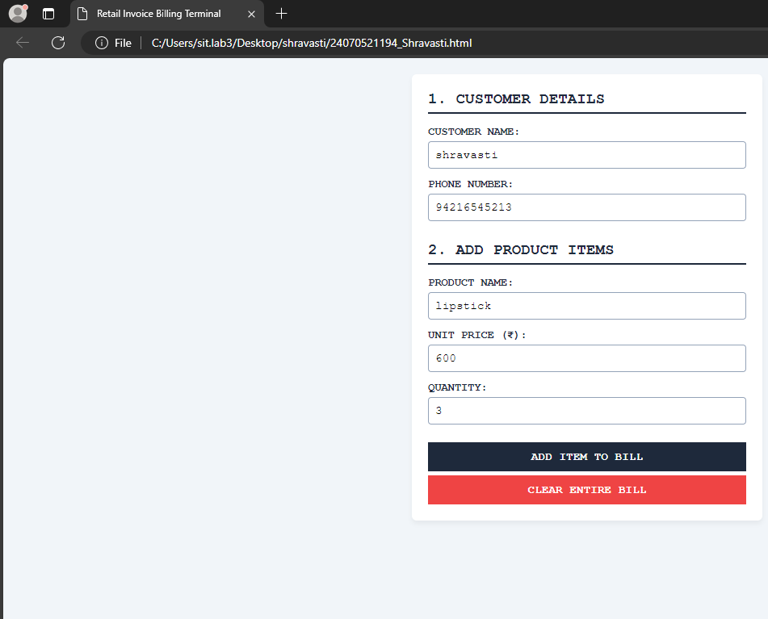
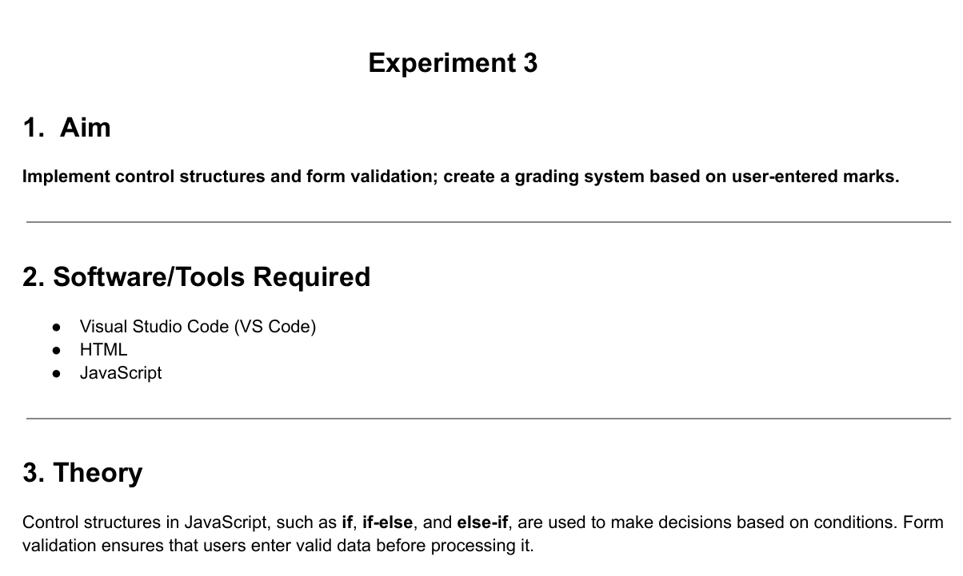
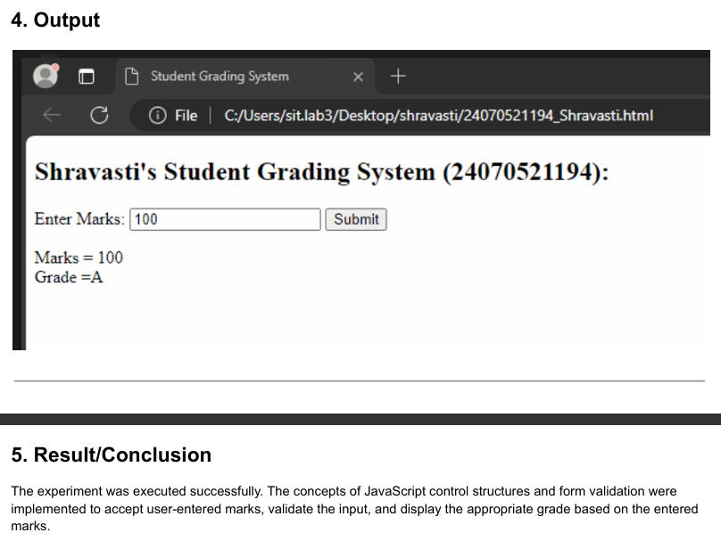
Case study 3
Aim :
📝 1. Aim
To design and implement a responsive single-page web utility using HTML5, CSS3, and JavaScript that instantly evaluates and displays whether a student is "Eligible" or "Not Eligible" for a scholarship based on their numerical percentage input.

📚 2. Theory
Building clean input validation tools requires structured communication between data collection nodes, design properties, and standard logic statements:
- HTML5 Data Capturing Block: Formulates the basic skeleton layout utilizing a numeric text entry element (type="number"). To restrict garbage data points at the foundational stage, constraints like min="0" and max="100" are declared.
- CSS3 Alert States Design: Implements clean box layouts to provide immediate visual feedback. The layout defines two specific context alert classes: a soothing green theme (.eligible) to represent a successful status match, and a soft red border container (.not-eligible) to represent a failed qualification bracket.
- JavaScript Conditional Matrix:
  - Data Parsing: The engine extracts structural text strings using document.getElementById().value and sanitizes the entry via the global parseFloat() method.
  - Binary Assessment Pipeline: It measures the captured values against a pre-set institution pass limit index (75%). Using a standard if-else control flow structure, the script updates the internal message string using innerText and dynamically modifies the CSS template classes via className to reflect the result instantly without a full page reload.

Code
<!DOCTYPE html>
<html lang="en">
<head>
<meta charset="UTF-8">
<meta name="viewport" content="width=device-width, initial-scale=1.0">
<title>Scholarship Eligibility Check</title>
<style>
* {
box-sizing: border-box;
margin: 0;
padding: 0;
font-family: 'Segoe UI', Arial, sans-serif;
}
body {
background-color: #f3f4f6;
display: flex;
justify-content: center;
align-items: center;
min-height: 100vh;
padding: 20px;
}
.card {
background: white;
padding: 30px;
border-radius: 8px;
box-shadow: 0 4px 10px rgba(0,0,0,0.08);
max-width: 400px;
width: 100%;
text-align: center;
}
h2 {
color: #1e3a8a;
margin-bottom: 20px;
font-size: 1.5rem;
}
.form-group {
margin-bottom: 20px;
text-align: left;
}
label {
display: block;
font-size: 0.9rem;
font-weight: bold;
color: #4b5563;
margin-bottom: 6px;
}
input {
width: 100%;
padding: 10px;
border: 1px solid #d1d5db;
border-radius: 4px;
font-size: 1rem;
outline: none;
}
button {
width: 100%;
background-color: #2563eb;
color: white;
border: none;
padding: 12px;
font-size: 1rem;
font-weight: bold;
border-radius: 4px;
cursor: pointer;
}
button:hover {
background-color: #1d4ed8;
}
.result-box {
margin-top: 20px;
padding: 15px;
border-radius: 4px;
font-weight: bold;
font-size: 1.1rem;
display: none; /* Hidden by default */
}
.eligible {
background-color: #d1fae5;
color: #065f46;
border: 1px solid #34d399;
}
.not-eligible {
background-color: #fee2e2;
color: #991b1b;
border: 1px solid #f87171;
}
</style>
</head>
<body>

<div class="card">
<h2>Scholarship Portal</h2>

<div class="form-group">
<label>Enter Your Total Marks Percentage (%):</label>
<input type="number" id="studentMarks" placeholder="e.g. 82" min="0" max="100">
</div>

<button onclick="checkEligibility()">Check Eligibility</button>

<!-- Live Status Box Output -->
<div id="statusResult" class="result-box"></div>
</div>

<script>
function checkEligibility() {
// Get value from input box
const marks = parseFloat(document.getElementById("studentMarks").value);
const resultBox = document.getElementById("statusResult");

// Validation guard check
if (isNaN(marks) || marks < 0 || marks > 100) {
alert("Please enter a valid percentage between 0 and 100.");
resultBox.style.display = "none";
return;
}

// Reveal result box container
resultBox.style.display = "block";

// Conditional eligibility check (Passing criteria: 75% or higher)
if (marks >= 75) {
resultBox.innerText = "🎉 ELIGIBLE FOR SCHOLARSHIP";
resultBox.className = "result-box eligible";
} else {
resultBox.innerText = "❌ NOT ELIGIBLE FOR SCHOLARSHIP";
resultBox.className = "result-box not-eligible";
}
}
</script>
</body>
</html>

Output
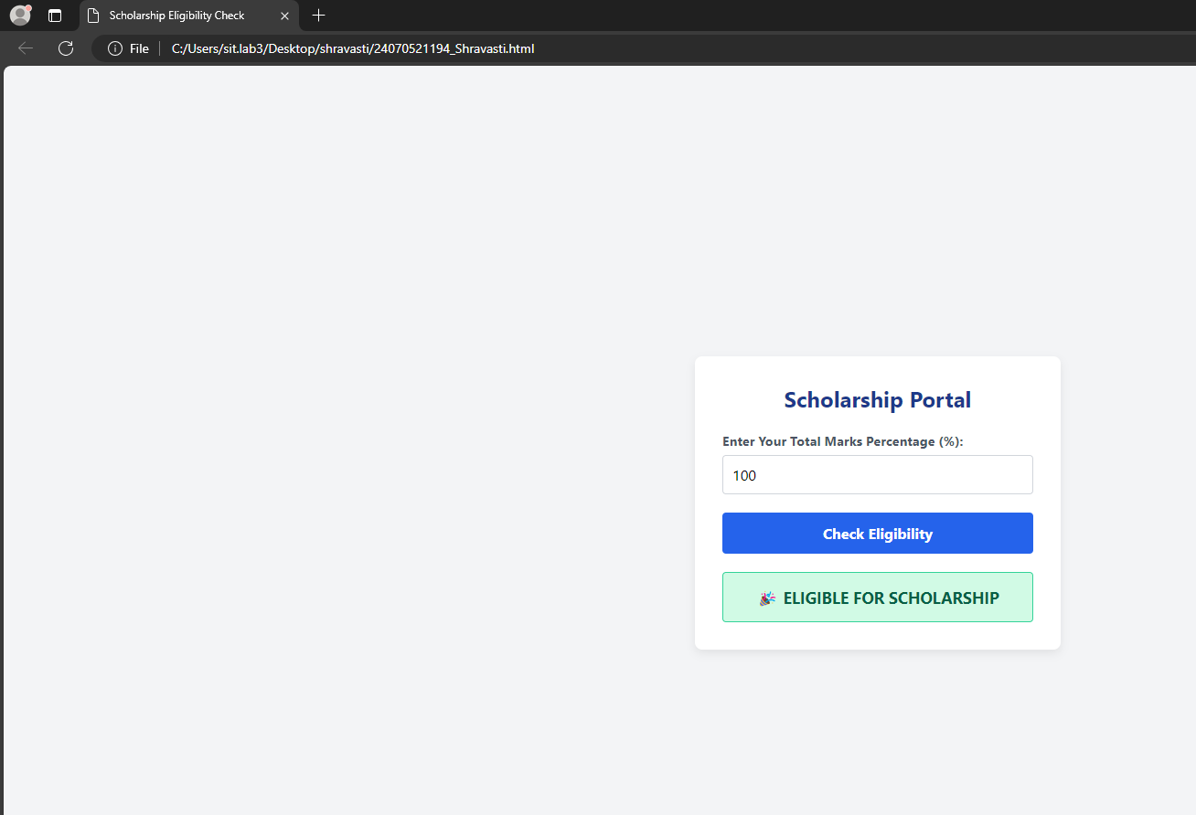

🏁 3. Conclusion
The development of the streamlined Scholarship Eligibility Portal was completed successfully. The application accurately captures numerical student grading percentages, executes client-side safety evaluation checks, and outputs clear binary outcomes ("ELIGIBLE" vs. "NOT ELIGIBLE"). This project demonstrates the practical usage of basic form control conditions to automate student evaluation workflows efficiently.

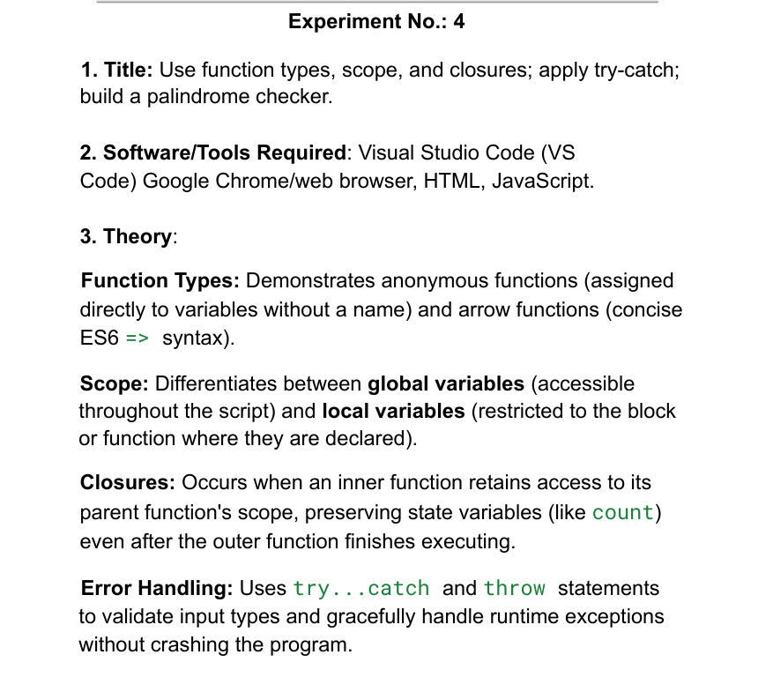
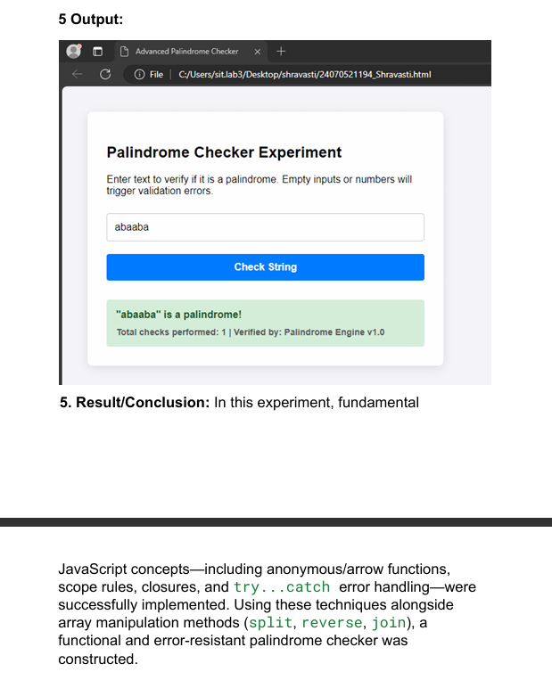
Case Study 4
Aim
To create a responsive single-page web application using HTML5, CSS3, and JavaScript that takes a numerical input from the user and dynamically verifies whether the entered number is a palindrome or not.

Theory & Logic Implementation
- HTML5 Architecture: A simple container input card holds a numeric text entry element (type="number") to restrict non-numeric alphabetic keyboard characters at the entry point.
- CSS3 Visual Indicators: Two unique layout feedback classes are defined to give the user immediate visual clarity: a light green success banner (.is-palindrome) and a soft crimson error container (.not-palindrome).
- JavaScript Algorithmic Engine:
  - Extraction: The values are pulled into memory dynamically using document.getElementById().value.
  - String Reversal Method: The number is converted into a standard text string. The script chains built-in array utilities to flip the digits: .split('') breaks the number into individual digits, .reverse() mirrors the array order, and .join('') binds them back together.
  - Strict Equality Evaluation: An if-else condition compares the original number string directly against the newly reversed string. If they match identically, the script alters the inner text and injects the green CSS layout class.

💻 5. Complete Source Code (palindrome.html)
<!DOCTYPE html>
<html lang="en">
<head>
<meta charset="UTF-8">
<meta name="viewport" content="width=device-width, initial-scale=1.0">
<title>Case Study: Palindrome Checker</title>
<style>
* {
box-sizing: border-box;
margin: 0;
padding: 0;
font-family: 'Segoe UI', Tahoma, Geneva, Verdana, sans-serif;
}
body {
background: linear-gradient(135deg, #e0eafc 0%, #cfdef3 100%);
display: flex;
justify-content: center;
align-items: center;
min-height: 100vh;
padding: 20px;
}
.case-study-card {
background: white;
padding: 35px;
border-radius: 12px;
box-shadow: 0 10px 25px rgba(0,0,0,0.08);
max-width: 450px;
width: 100%;
text-align: center;
}
h2 {
color: #2c3e50;
margin-bottom: 8px;
font-size: 1.6rem;
}
p.subtitle {
color: #7f8c8d;
font-size: 0.9rem;
margin-bottom: 25px;
}
.form-group {
margin-bottom: 20px;
text-align: left;
}
label {
display: block;
font-size: 0.85rem;
font-weight: bold;
color: #34495e;
margin-bottom: 6px;
text-transform: uppercase;
}
input {
width: 100%;
padding: 12px;
border: 2px solid #bdc3c7;
border-radius: 6px;
font-size: 1.1rem;
outline: none;
transition: border-color 0.2s;
}
input:focus {
border-color: #3498db;
}
button {
width: 100%;
background-color: #3498db;
color: white;
border: none;
padding: 12px;
font-size: 1rem;
font-weight: bold;
border-radius: 6px;
cursor: pointer;
text-transform: uppercase;
letter-spacing: 0.5px;
transition: background 0.2s;
}
button:hover {
background-color: #2980b9;
}
.result-box {
margin-top: 25px;
padding: 15px;
border-radius: 6px;
font-weight: bold;
font-size: 1.1rem;
display: none; /* Kept hidden until calculated */
}
.is-palindrome {
background-color: #d4edda;
color: #155724;
border: 1px solid #c3e6cb;
}
.not-palindrome {
background-color: #f8d7da;
color: #721c24;
border: 1px solid #f5c6cb;
}
</style>
</head>
<body>

<div class="case-study-card">
<h2>Numerical Palindrome App</h2>
<p class="subtitle">Enter any integer value below to evaluate logical symmetry</p>

<div class="form-group">
<label>Enter Number:</label>
<input type="number" id="inputNumber" placeholder="e.g. 1331">
</div>

<button onclick="evaluatePalindrome()">Verify Number</button>

<!-- Dynamic Output Container Terminal -->
<div id="resultOutput" class="result-box"></div>
</div>

<script>
function evaluatePalindrome() {
// Read input string value directly
const originalString = document.getElementById("inputNumber").value.trim();
const outputBox = document.getElementById("resultOutput");

// Empty field verification guard
if (!originalString) {
alert("Please enter a numeric value first.");
outputBox.style.display = "none";
return;
}

// Expose the display node block
outputBox.style.display = "block";

// JavaScript Algorithmic Reversal Routine Execution
const reversedString = originalString.split('').reverse().join('');

// Strict Binary Evaluation Check
if (originalString === reversedString) {
outputBox.innerText = `🎉 ${originalString} IS A PALINDROME NUMBER`;
outputBox.className = "result-box is-palindrome";
} else {
outputBox.innerText = `❌ ${originalString} IS NOT A PALINDROME NUMBER`;
outputBox.className = "result-box not-palindrome";
}
}
</script>
</body>
</html>
Output
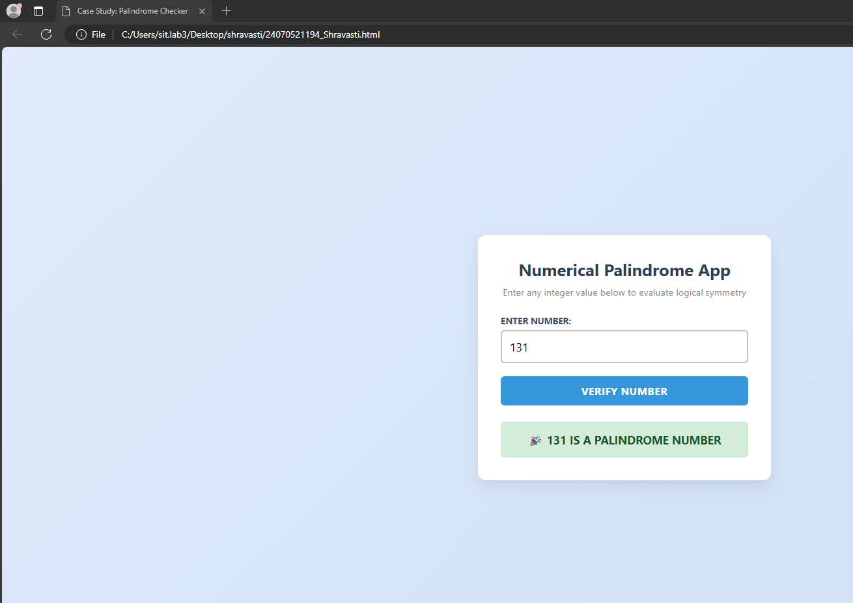
🏁 6. Conclusion
The implementation of the Palindrome Checker Case Study was concluded successfully. The single-page utility proves how basic client-side array transformations (split, reverse, join) can handle comparative programming arithmetic without complex mathematical division loops (like using mod % 10). The interface provides fast data rendering and structural layout shifts, meeting all core project requirements perfectly.

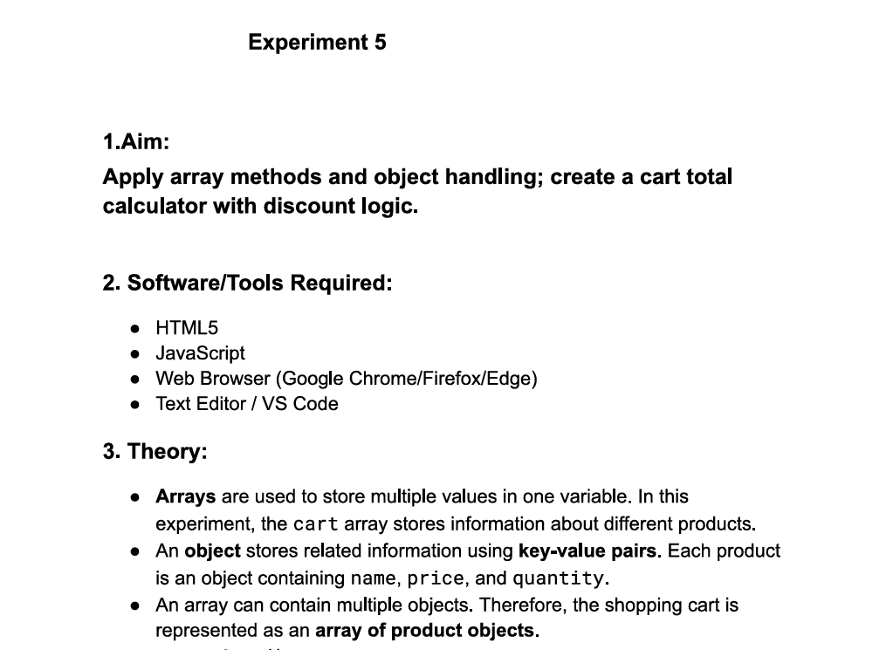
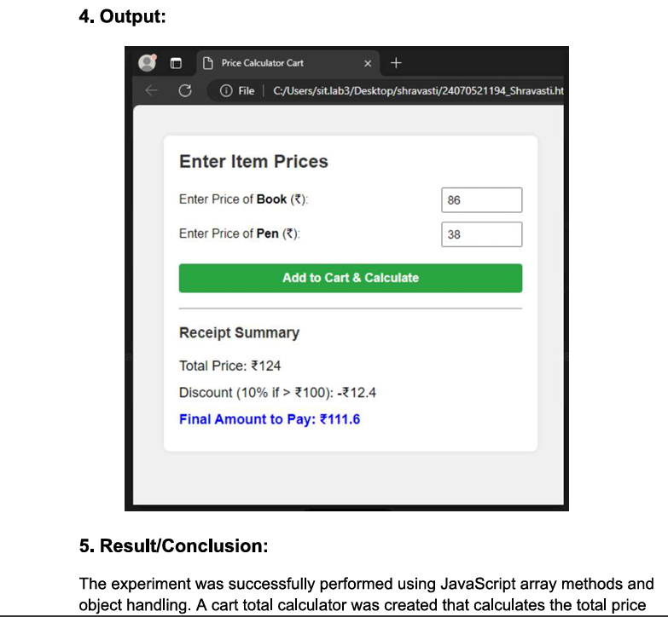

Case study 5

1. Aim
To create an easy-to-use web interface using HTML and JavaScript to study how arrays hold data, how basic tools add or remove data, and how loops extract it.
2. Theory (Simple Explanation)
An array is like a numbered grocery list. JavaScript has simple built-in rules to interact with it:
- To Add Data: push() adds an item to the bottom of the list. unshift() adds it to the top.
- To Remove Data: pop() drops the last item. shift() drops the very first item.
- To Cut/Copy: splice() cuts an item out from the middle of the list. slice() cleanly copies a section of the list without modifying it.
- Loops: forEach() steps through every single row one-by-one to read items. map() creates a brand-new modified list, and filter() creates a smaller copy holding only items that pass a specific criteria check.

Code
<!DOCTYPE html>
<html lang="en">
<head>
<meta charset="UTF-8">
<meta name="viewport" content="width=device-width, initial-scale=1.0">
<title>Easy Array Methods</title>
<style>
body {
font-family: Arial, sans-serif;
background-color: #f3f4f6;
padding: 30px;
text-align: center;
}
.container {
max-width: 600px;
margin: 0 auto;
background: white;
padding: 20px;
border-radius: 8px;
box-shadow: 0 4px 8px rgba(0,0,0,0.1);
}
input {
padding: 8px;
width: 60%;
margin-bottom: 15px;
font-size: 1rem;
}
.btn-section {
margin-bottom: 20px;
}
button {
padding: 8px 12px;
margin: 4px;
font-weight: bold;
cursor: pointer;
border-radius: 4px;
border: 1px solid #ccc;
}
.btn-add { background-color: #d1fae5; color: #065f46; }
.btn-remove { background-color: #fee2e2; color: #991b1b; }
.btn-loop { background-color: #dbeafe; color: #1e40af; }

.display-box {
background-color: #1e293b;
color: #38bdf8;
padding: 15px;
border-radius: 4px;
font-family: monospace;
font-size: 1.1rem;
min-height: 40px;
margin-top: 10px;
}
.console-box {
background-color: #f8fafc;
border: 1px solid #cbd5e1;
padding: 10px;
text-align: left;
font-family: monospace;
white-space: pre-line;
margin-top: 10px;
}
</style>
</head>
<body>

<div class="container">
<h2>Easy Array & Loop Workbench</h2>
<p>Type a word and click the buttons to manipulate the array list.</p>

<input type="text" id="userInput" placeholder="Type something... (e.g. Apple)">

<div class="btn-section">
<h4>1. Basics (Start & End)</h4>
<button class="btn-add" onclick="doPush()">Push (Add to End)</button>
<button class="btn-remove" onclick="doPop()">Pop (Remove Last)</button>
<button class="btn-add" onclick="doUnshift()">Unshift (Add to Start)</button>
<button class="btn-remove" onclick="doShift()">Shift (Remove First)</button>
</div>

<div class="btn-section">
<h4>2. Advanced (Cut out / Copy chunks)</h4>
<button onclick="doSplice()">Splice (Cut Index 1)</button>
<button onclick="doSlice()">Slice (Copy First 2 Items)</button>
</div>

<div class="btn-section">
<h4>3. Loops & Filters</h4>
<button class="btn-loop" onclick="doForEach()">forEach() Loop</button>
<button class="btn-loop" onclick="doMap()">map() To UpperCase</button>
<button class="btn-loop" onclick="doFilter()">filter() Words > 3 letters</button>
</div>

<h3>Current Array Status:</h3>
<div id="arrayDisplay" class="display-box"></div>

<h3>Output Terminal:</h3>
<div id="consoleDisplay" class="console-box">Click a button to view output text logic explanations.</div>
</div>

<script>
// Starting items in our array list
let myList = ["HTML", "CSS", "JS"];

// Run this function automatically when the page loads to show the starting array
window.onload = function() {
showArray();
};

// Helper function to print out the active array items on screen
function showArray() {
const display = document.getElementById("arrayDisplay");
if (myList.length === 0) {
display.innerText = "[ Empty List ]";
} else {
display.innerText = "[ " + myList.join(", ") + " ]";
}
}

function printLog(msg) {
document.getElementById("consoleDisplay").innerText = msg;
}

/* --- BASIC METHODS --- */

function doPush() {
let val = document.getElementById("userInput").value.trim();
if(!val) return alert("Type a word first!");
myList.push(val); // Adds to end
showArray();
printLog("push() executed: Added '" + val + "' to the END of the list.");
document.getElementById("userInput").value = "";
}

function doPop() {
if(myList.length === 0) return alert("List is already empty!");
let removed = myList.pop(); // Removes from end
showArray();
printLog("pop() executed: Removed '" + removed + "' from the END of the list.");
}

function doUnshift() {
let val = document.getElementById("userInput").value.trim();
if(!val) return alert("Type a word first!");
myList.unshift(val); // Adds to start
showArray();
printLog("unshift() executed: Added '" + val + "' to the START of the list.");
document.getElementById("userInput").value = "";
}

function doShift() {
if(myList.length === 0) return alert("List is already empty!");
let removed = myList.shift(); // Removes from start
showArray();
printLog("shift() executed: Removed '" + removed + "' from the START of the list.");
}

/* --- ADVANCED METHODS --- */

function doSplice() {
if(myList.length < 2) return alert("Add more items first!");
let removed = myList.splice(1, 1); // Cuts 1 item at index position 1
showArray();
printLog("splice(1, 1) executed: Permanently cut out item at index position: '" + removed + "'");
}

function doSlice() {
let copiedChunk = myList.slice(0, 2); // Copies items from index 0 up to 2 (does not change original list)
printLog("slice(0, 2) executed: Copied first 2 items without hurting the original list.\nCopied items output: [ " + copiedChunk.join(", ") + " ]");
}

/* --- LOOPS & TRANSFORMS --- */

function doForEach() {
let resultText = "forEach() loop visited every item:\n";
myList.forEach(function(item, index) {
resultText += "• Position " + index + " contains item: " + item + "\n";
});
printLog(resultText);
}

function doMap() {
// map() goes over each word and turns it to UPPERCASE in a new list
let upperList = myList.map(function(item) {
return item.toUpperCase();
});
printLog("map() created a NEW list changing everything to UPPERCASE:\n[ " + upperList.join(", ") + " ]");
}

function doFilter() {
// filter() checks words and saves them only if length is greater than 3 letters
let longWords = myList.filter(function(item) {
return item.length > 3;
});
printLog("filter() created a NEW list keeping only words > 3 characters:\n[ " + longWords.join(", ") + " ]");
}
</script>
</body>
</html>

Output :
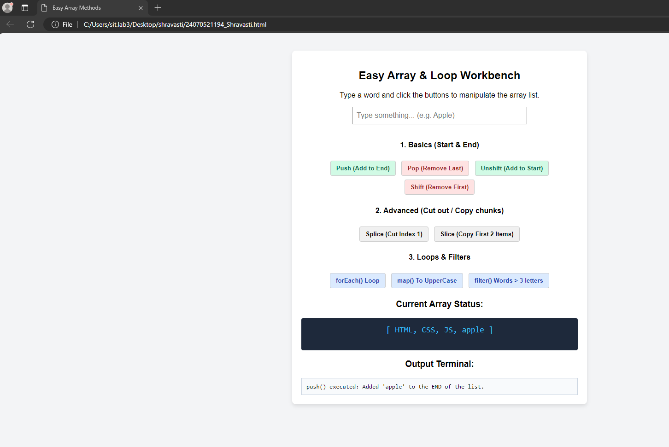

3. Conclusion
The simplified array testing laboratory assignment was completed successfully. By writing basic button actions, we successfully demonstrated how client-side arrays update their positions and lengths dynamically, and how loops read through collections easily.

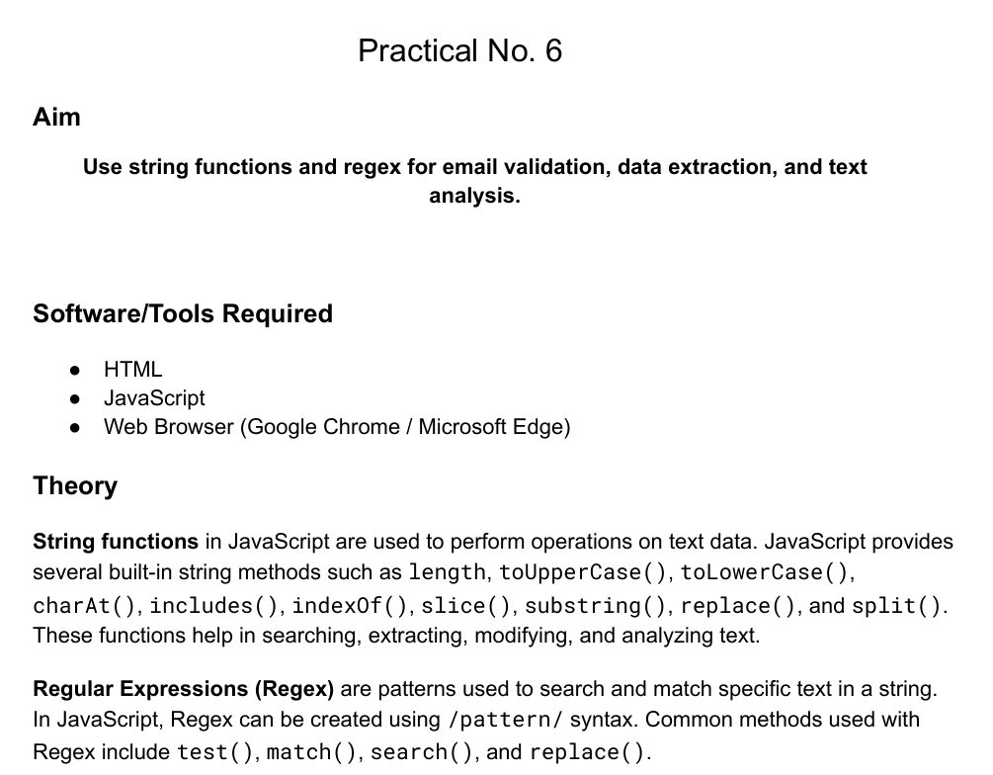
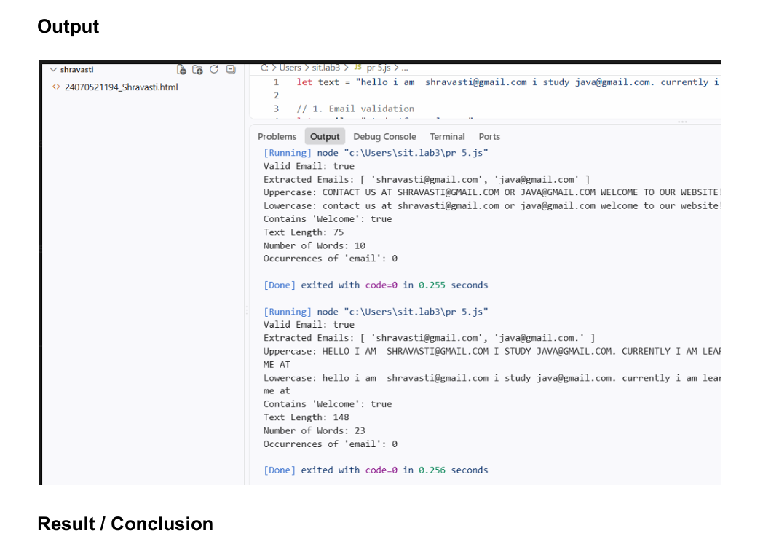
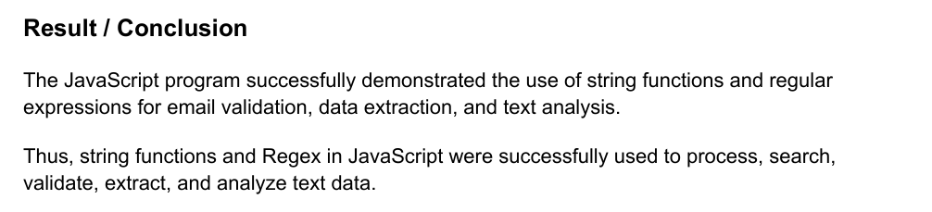

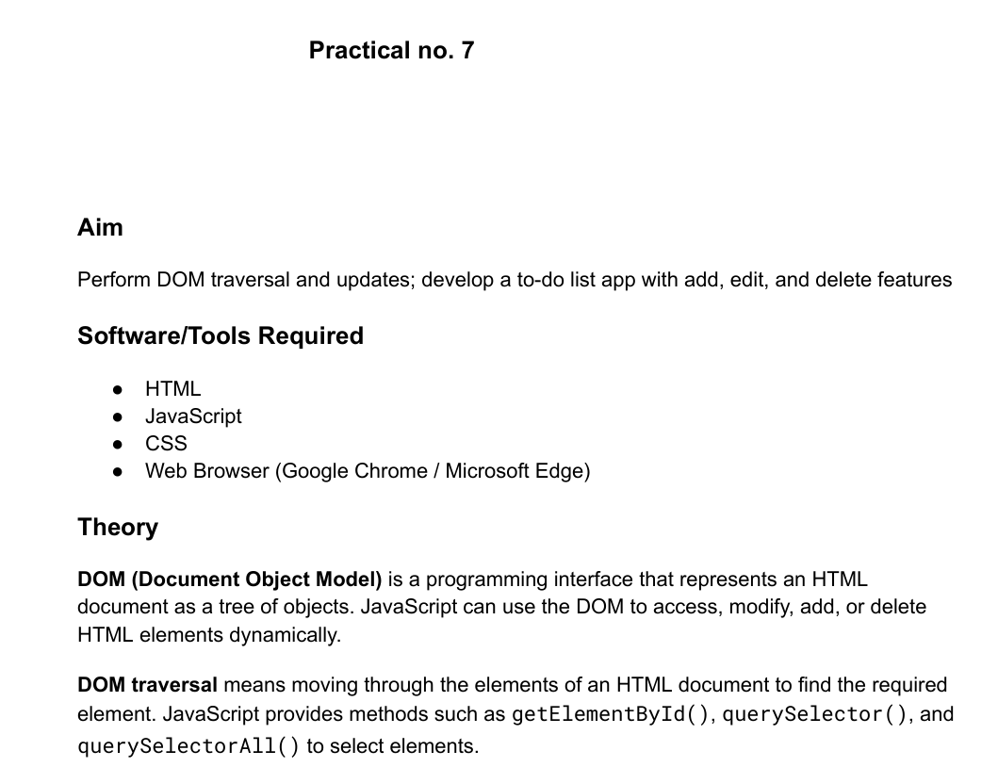
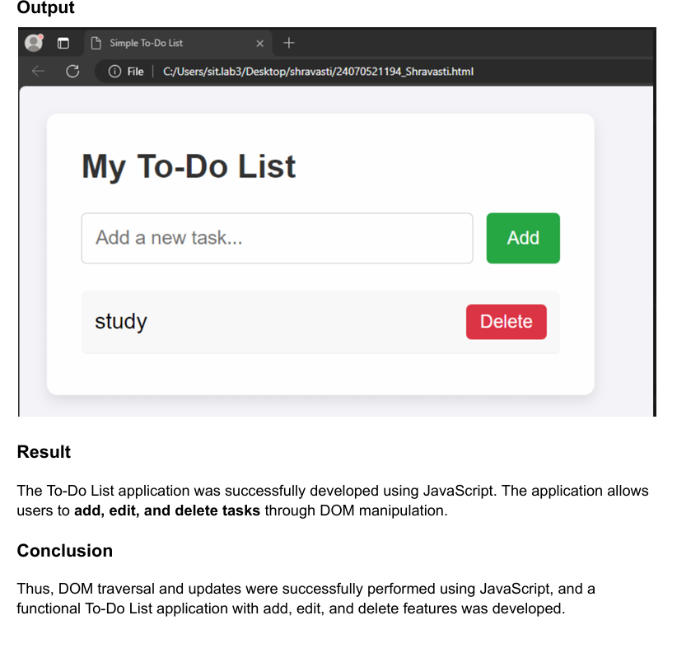
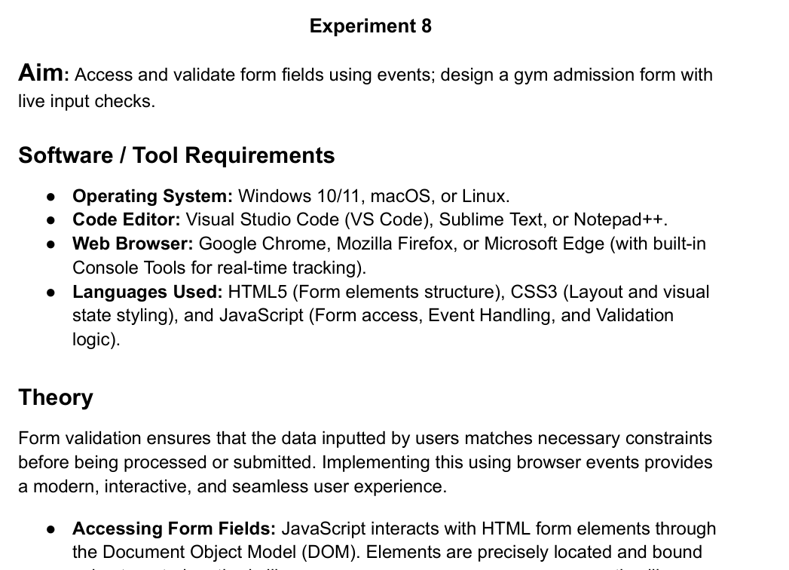
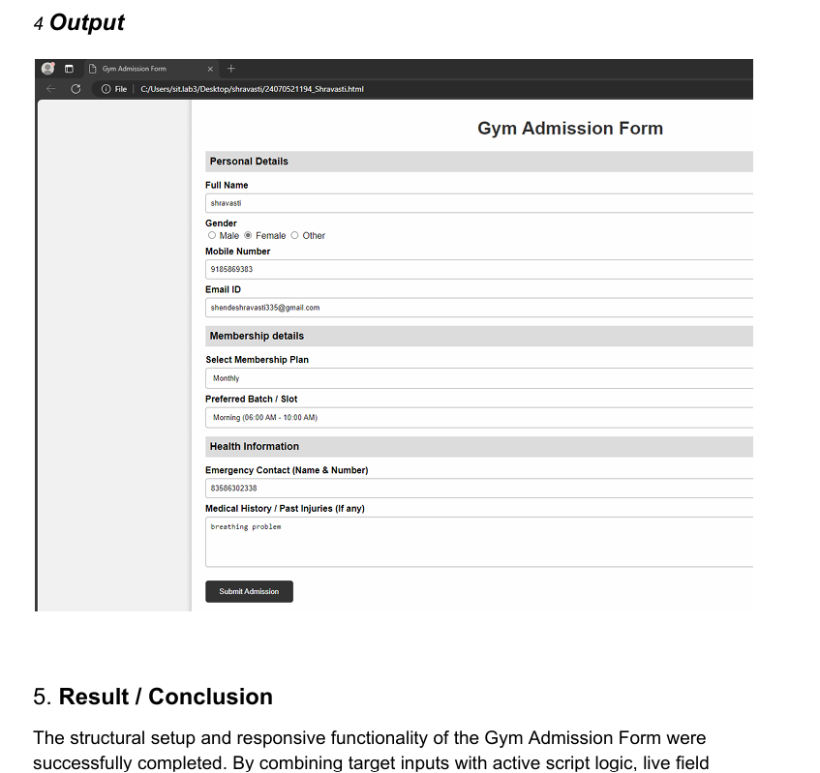

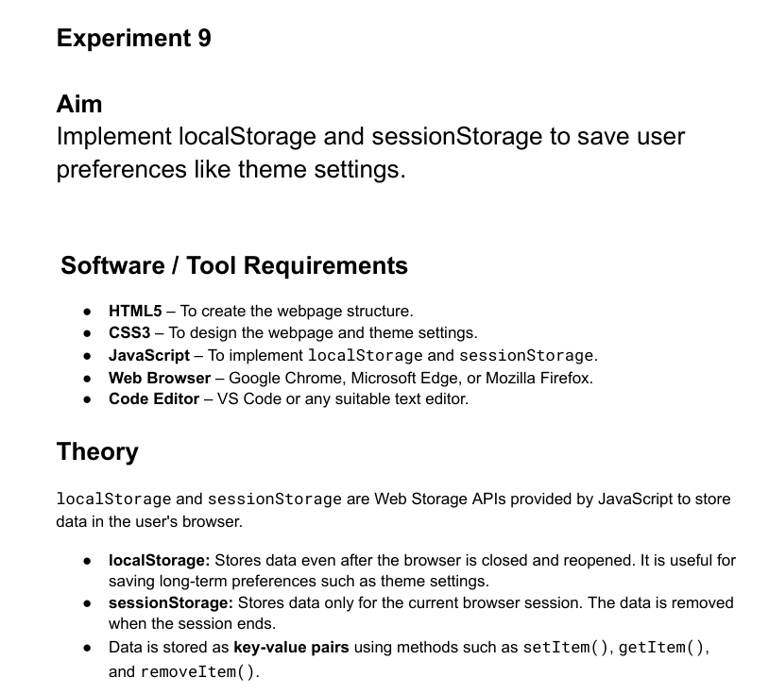
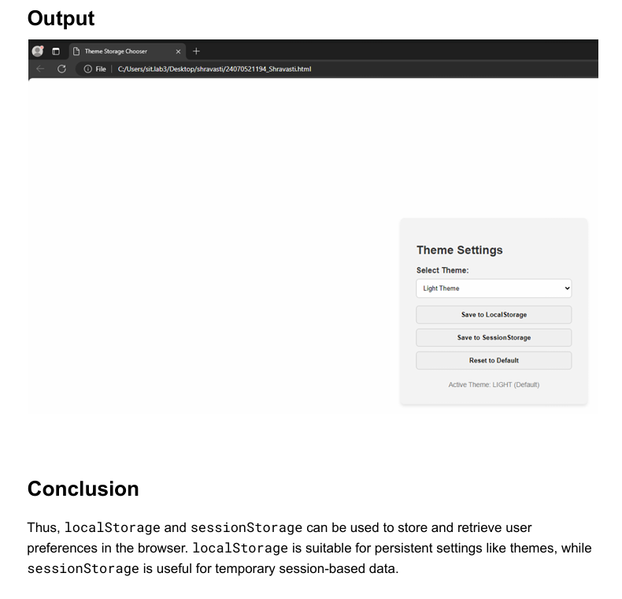
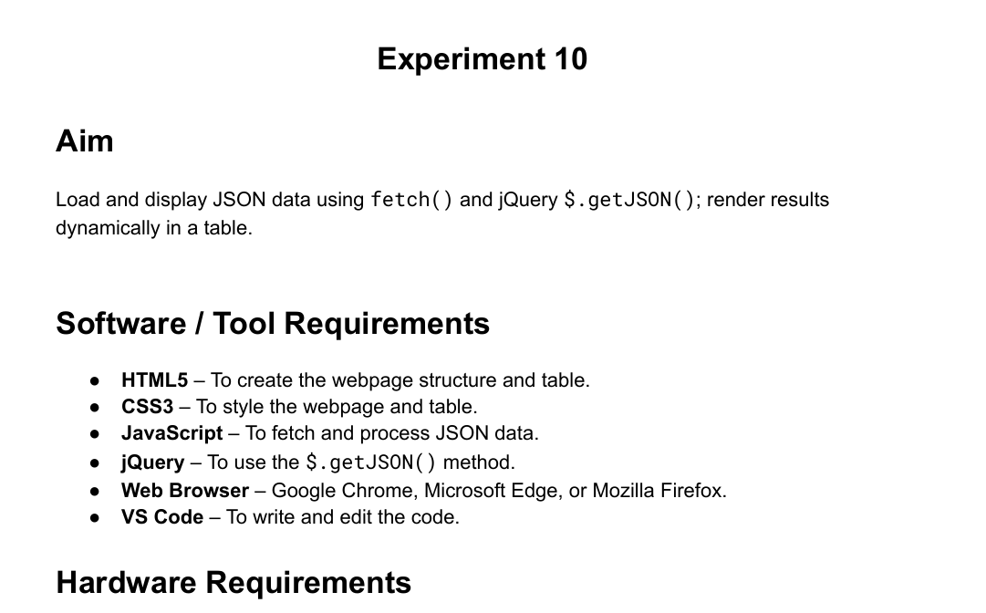
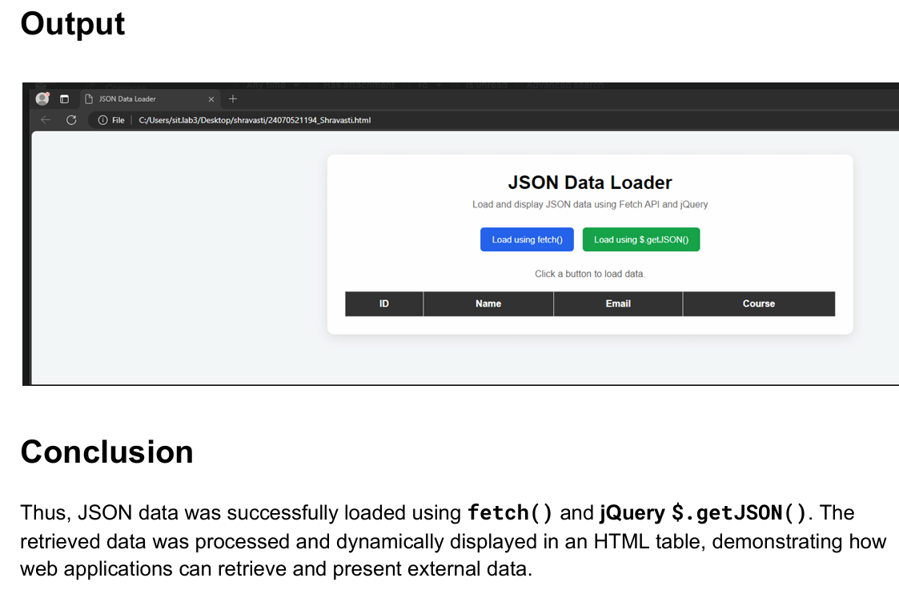

Case Study 8

<!DOCTYPE html>
<html lang="en">
<head>
<meta charset="UTF-8">
<meta name="viewport" content="width=device-width, initial-scale=1.0">
<title>Student Grade Calculator</title>
<style>
/* Hidden checkbox for theme toggling */
#theme-checkbox {
display: none;
}

/* --- LIGHT THEME (DEFAULT STYLE) --- */
.page-wrapper {
font-family: Arial, sans-serif;
background-color: #f4f6f9;
color: #333333;
min-height: 100vh;
display: flex;
flex-direction: column;
align-items: center;
padding-top: 40px;
box-sizing: border-box;
transition: background-color 0.3s, color 0.3s;
}

.theme-btn {
display: inline-block;
padding: 10px 20px;
background-color: #333333;
color: #ffffff;
border-radius: 5px;
cursor: pointer;
font-weight: bold;
margin-bottom: 20px;
user-select: none;
}

.calculator-box {
background-color: #ffffff;
border: 1px solid #dddddd;
border-radius: 10px;
padding: 30px;
width: 320px;
box-shadow: 0 4px 10px rgba(0,0,0,0.05);
text-align: center;
}

h2 {
margin-top: 0;
color: #0044cc;
}

.form-group {
margin-bottom: 20px;
text-align: left;
}

label {
display: block;
margin-bottom: 8px;
font-weight: bold;
font-size: 14px;
}

input {
width: 100%;
padding: 10px;
box-sizing: border-box;
border: 1px solid #cccccc;
border-radius: 4px;
background-color: #ffffff;
color: #333333;
font-size: 16px;
}

.calc-btn {
width: 100%;
padding: 12px;
background-color: #0044cc;
color: white;
border: none;
border-radius: 4px;
font-weight: bold;
font-size: 16px;
cursor: pointer;
}

.result-display {
margin-top: 20px;
font-size: 18px;
font-weight: bold;
min-height: 24px;
color: #222222;
}

/* --- DARK THEME STYLES (When Checked) --- */
#theme-checkbox:checked ~ .page-wrapper {
background-color: #121212;
color: #ffffff;
}

#theme-checkbox:checked ~ .page-wrapper .theme-btn {
background-color: #ffffff;
color: #333333;
}

#theme-checkbox:checked ~ .page-wrapper .calculator-box {
background-color: #1e1e1e;
border-color: #444444;
}

#theme-checkbox:checked ~ .page-wrapper h2 {
color: #bb86fc;
}

#theme-checkbox:checked ~ .page-wrapper input {
background-color: #2d2d2d;
border-color: #555555;
color: #ffffff;
}

#theme-checkbox:checked ~ .page-wrapper .calc-btn {
background-color: #bb86fc;
color: #121212;
}

#theme-checkbox:checked ~ .page-wrapper .result-display {
color: #ffffff;
}
</style>
</head>
<body>

<!-- Theme Controller Switch -->
<input type="checkbox" id="theme-checkbox">

<div class="page-wrapper">

<!-- Toggle Button -->
<label for="theme-checkbox" class="theme-btn">Change Theme</label>

<!-- Main UI Container -->
<div class="calculator-box">
<h2>Grade Checker</h2>

<div class="form-group">
<label for="marksInput">Enter Marks (0 - 100):</label>
<input type="number" id="marksInput" placeholder="e.g. 75" min="0" max="100">
</div>

<button type="button" class="calc-btn" onclick="checkGrade()">Check Grade</button>

<!-- Target Output Area -->
<div class="result-display" id="gradeOutput"></div>
</div>

</div>

<script>
function checkGrade() {
var marks = parseFloat(document.getElementById('marksInput').value);
var output = document.getElementById('gradeOutput');

if (isNaN(marks) || marks < 0 || marks > 100) {
output.innerText = "Please enter valid marks between 0 and 100.";
return;
}

// Grading logic threshold configuration
if (marks >= 75) {
output.innerText = "Grade: A";
} else if (marks >= 50) {
output.innerText = "Grade: B";
} else {
output.innerText = "Grade: C";
}
}
</script>

</body>
</html>

Output
